Parent Portal Directions

**Parents New to Chandler:**

**Please visit your school to receive a Portal Activation Letter**

**To register for the Parent Portal, please click below and follow these instructions:**

https://campus.cusd80.com/campus/portal/chandler.jsp

1. From the Portal Login page, **Click Help**.
2. Select the first **Click Here** option “If you have been assigned a Campus Portal Activation Key, [click here](https://campus.cusd80.com/campus/portal/chandler.jsp?section=activate)”which requires a **Portal Activation Key** (on your activation letter).
3. Next the **Activation Screen** will display. This is where you enter your **Activation Key provided to you by your school on the letter.** Once the Activation Key has been used to create an account, it cannot be used again.
4. Click **Submit**. The Activation Key will be verified, and when approved, a screen will prompt you to create a username and password.
5. Enter a **Username**. It is best to use an alphanumeric username (containing both letters and numbers).
6. Enter a **Password**. Again, it is best to use an alphanumeric password. Passwords should be at least 6 characters long. A **Strong Password** must meet three of the four qualifications:
   * A lower case letter (a, j, r, etc.)
   * An upper case letter (A, J, R, etc.)
   * A number (3, 7, 1, etc.)
   * A symbol (@, %, &, etc.)
7. Re-enter the password in the **Verify Password**

**\*If you forget your password, please contact your school for assistance\***

**Returning Parents:**

Your username and password have not changed. You will have the same username and password for the remainder of your child’s education with Chandler Unified School District.

**\*If you forgot your password, please contact your school for assistance\***

**Phone App:** 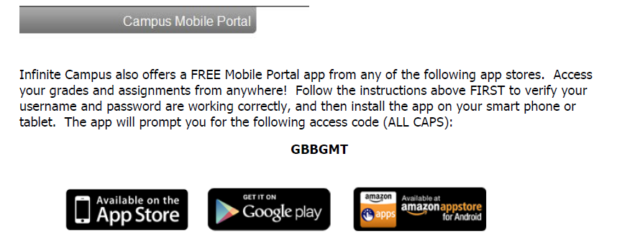

If you used last year’s password, it is still working and you will be able to view information from your phone.

**New This Year (Phone App Only):**

Push notifications will be available for parents and students after the first month of school. In order to receive push notifications for attendance and grade events, you must change your settings and choose **ON** under the Notifications section. Once the district has activated this feature, you will be able to switch it on.